**Exam statistics**

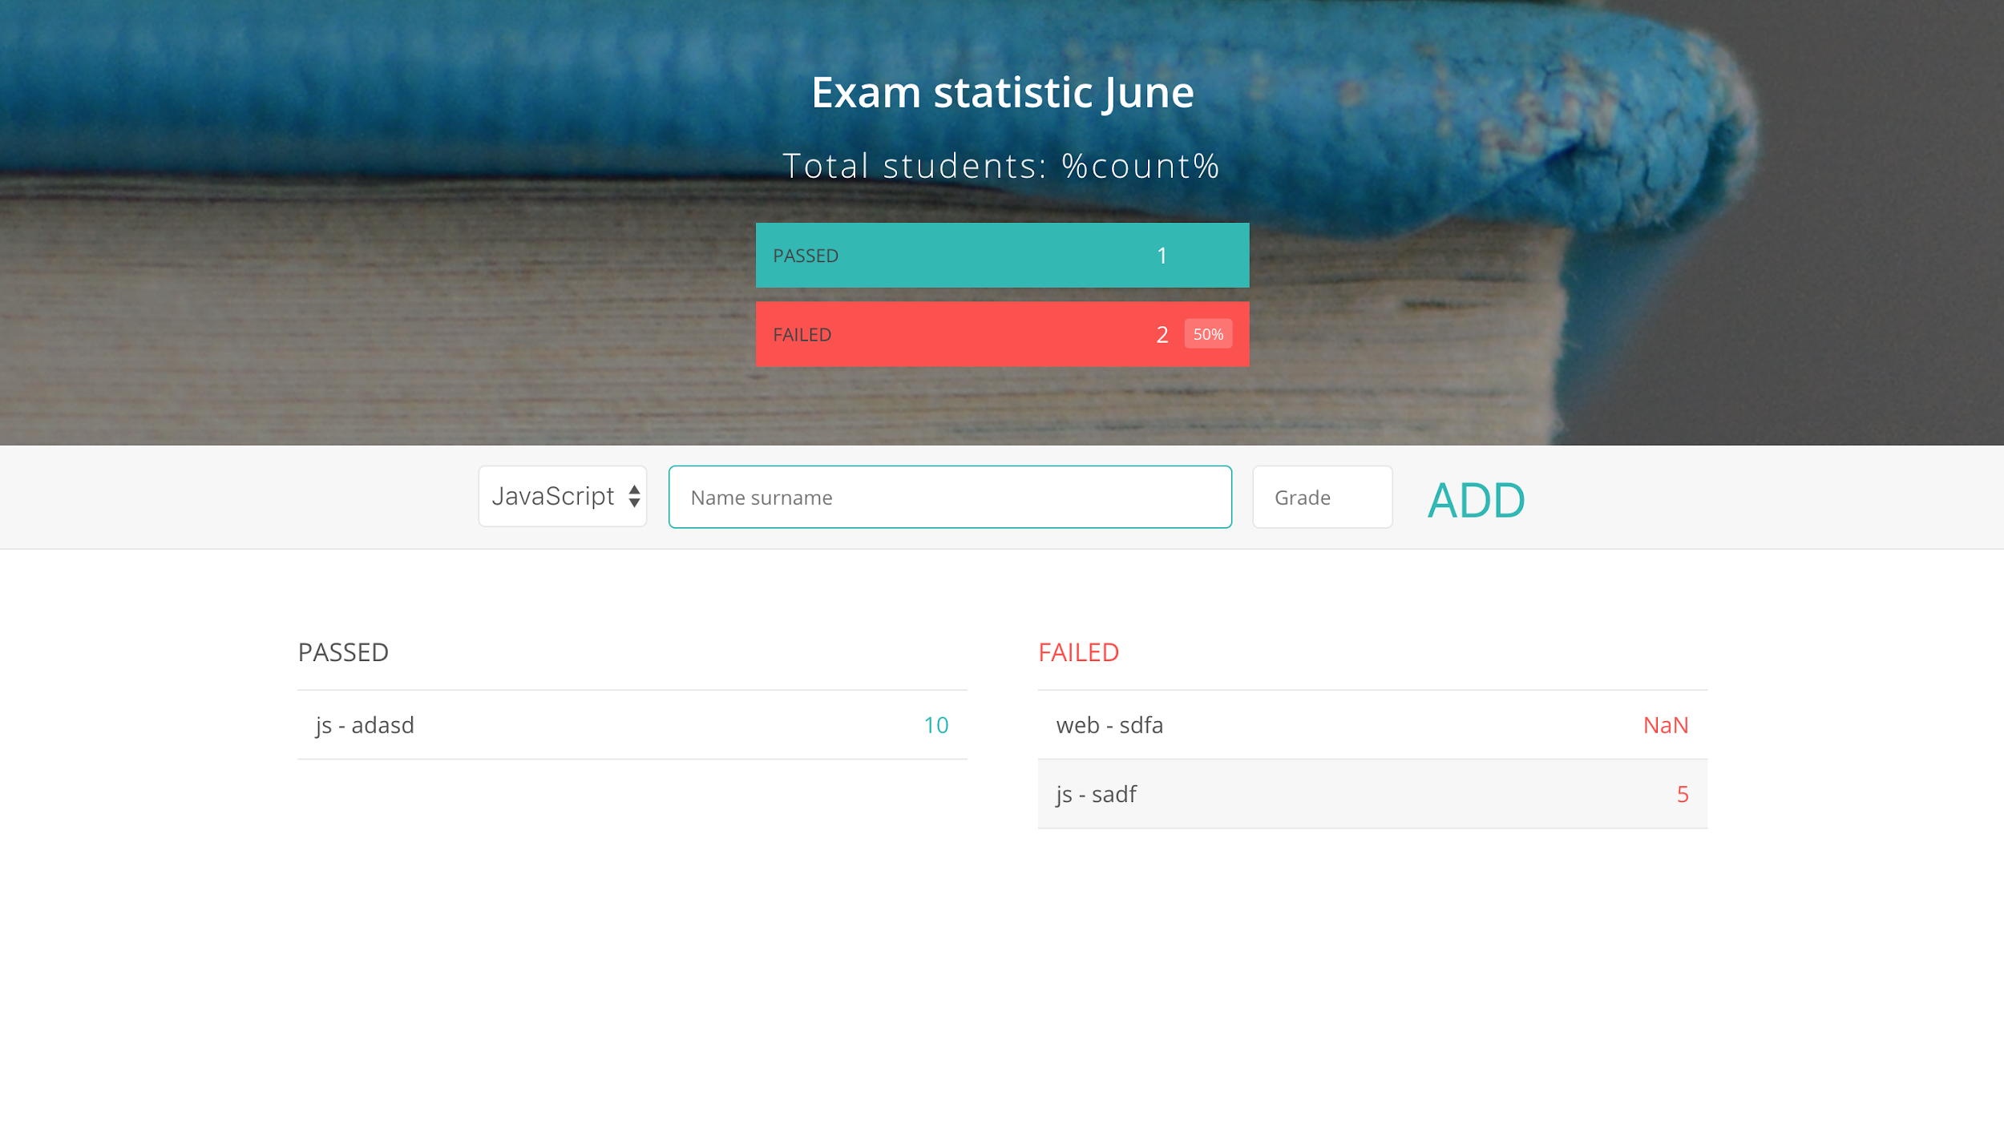

The goal of this exercise is to write a code for the web application that helps with the exam statistics.

The application should be developed with the following use-case scenario on mind. Firstly, a user can select the name of the subject from the select list provided in the left part of the form. Then, the user can type in the name and surname of the student. Finally, the user can select a grade from the list provided in the right part of the form. When the user clicks on the ADD button, the information about student and subject appears on the list titled with *passed* or *failed* depending on their score. Synchronously, the exam statistics presented in the page header is updated. That is the number of students that have passed the exam, and both the number and the percentage of the students who has failed the exam.

If provided input is not valid, appropriate error messages should be shown.

Both name and surname should be provided and both should start with capitals. A grade should be valid numerical value from 1 to 10.

**You should organize your working directory in the following manner:**

**CSS:**

main.css

**JS:**

subject.js

student.js

exam.js

form.js

app.js

**index.html**

In **index.html** file write all code relevant for the given page structure.

In **main.css** file write all CSS code relevant for the given page design.

In **subject.js** file:

* write a constructor function with one argument that represents the name of the subject
* add to its prototype a method *getSubjectName* that returns the subject name

**In student.js file:**

* write a constructor function with two arguments that represent name and surname of a student
* add to its prototype a method *getStudentData* that returns the name and surname of the student

**In exam.js file:**

* write a constructor function with three arguments that represent a subject, a student, and a grade.
* add to its prototype a method *getExamInfo* that returns the name of the subject and the name and surname of the student.
* add to its prototype a method *hasPassed* that checks if the student has passed the exam. A student has passed the exam if their grade is greater than 5.

**In form.js file:**

* write a function that collects all the data from the form
* write a function that validates all collected data
* write a function that updates the given list so it adds the new item at the end of the list
* write a function that updates the part of the page with the statistics

In **app.js** file:

* Declare all necessary variables for managing passed and failed exams as well as their statistics.
* Write all code that connects a user behaviour with application logic.